JAEGER-lCoultre

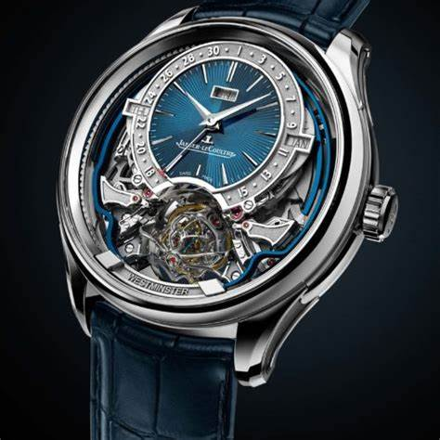DESCRIPTION: Jaeger-LeCoultre is a prestigious Swiss luxury watch brand renowned for its innovation, precision, and elegant craftsmanship. Founded in 1833 in the Vallée de Joux, Switzerland, the brand has played a pivotal role in advancing horology, developing over 1,200 calibers and holding hundreds of patents.

Jaeger-LeCoultre is best known for its iconic **Reverso**, a timeless Art Deco-inspired watch with a reversible case, originally designed for polo players. Other notable collections, such as the **Master**, **Polaris**, and **Atmos**, showcase the brand’s expertise in complications, ultra-thin movements, and perpetual motion technology.